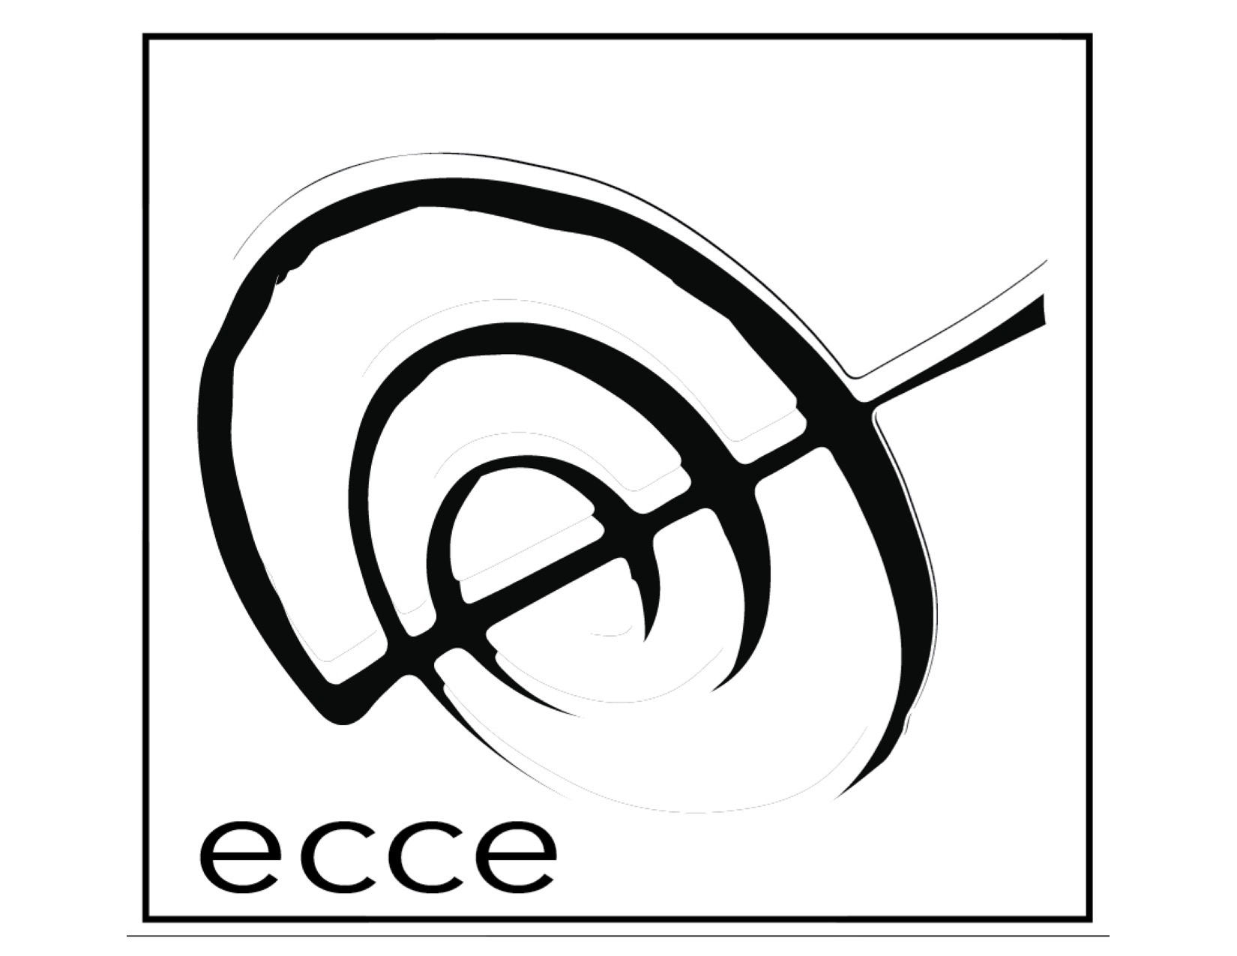

Etchings 2018 Application Form:

In one single email, please send us the following:

- This application form (either doc or pdf)
- Bio/Resume (max. 200 words) in pdf format.
- 2 scores of chamber ensemble work (may include solo or works involving electronic) in pdf format.
- 1 recording (this is optional, but please only submit instrumental recordings—no MIDI) You may also submit links to recordings/scores if they are too large to attach in you email. Links must remain active beyond the application deadline. Do not submit links to downloads (dropbox, yousendit, etc.)
- Email your completed application to eccemailbox@gmail.com

Last Name:___________________________

First (Given) Name: _______________________________

Date of Birth (MM/DD/YYYY): _____/______/________ Current Age:_______

Place of Birth: ___________________________

Nationality (country of passport you will be using): ___________________________

Languages:____________________________________________

Permanent Street Address (where you can be reached): ________________________

City/Town:___________________ State/Province:____________

Country:__________________________ Postal Code: __________

Telephone number: _________________________

E-mail Address (please print clearly): ___________________________

How did you hear about us? ______________________________________

Education: List all undergraduate and graduate degrees (include any programs in which you are currently enrolled). List degree, institution and date received.

_______________________________________________________________________

_______________________________________________________________________

______________________________________________________________________

List any special or significant achievements you would like to share (optional)

_______________________________________________________________________

_______________________________________________________________________

_______________________________________________________________________

Please list the scores and/or recordings you are submitting in your application:

_______________________________________________________________________

_______________________________________________________________________

_______________________________________________________________________

_______________________________________________________________________

_______________________________________________________________________

_______________________________________________________________________

Signature:_________________________________________________Date:__________

